**Mobile Application for Smart Parking of a Vehicle**

**Submitted By**

**SHRAVAN KUMAR REDDY POCHAMPALLY**

***Abstract: -*** *Parking a vehicle has become a difficult task to the people living in a densely populated cities. The drivers used to roam around the streets to find a space for parking, it consumes lot of time and gas. According to a report, using the parking applications can save 2 20,000 gallons of gas till 2030. Therefore, the mobile application for finding an available parking spots can become an important asset to the users. This smart parking application provides the feature to easily ‘park and pay’ using mobile. The user interface and other features of the application makes user more comfortable and faster while parking, like QR reader to recognize parking spot details and tracking parked vehicle etc.*

1. **INTRODUCTION**

Now a days, advancement in the technology makes the daily life activities more comfortable, mobile devices are becoming more popular and powerful and are providing a new notion of communication that we could once only imagine. The Smartphone’s help in the social life, health sectors, education and business. People travel from one place to another place in vehicles to accomplish their business activities but most of them facing difficulties in finding a place for parking a vehicle. Parking control is primarily an issue in relatively densely populated cities and towns where the demand/supply situation for parking spaces makes parking facilities dear and difficult. Parking lots are a feature of every city and suburban area. Most commonly we find the Parking in Shopping malls, Airports, Railway stations, bus stations, restaurants, cinema halls, stadiums etc.

The main scope of this application is providing availability of parking lots and easy parking by simply scanning the barcode in the particular block pole to get the parking details, where our vehicle has parked and start the parking timer, while returning to the car, the user opens the application and stop the timer to generate the bill of parking before leaving. We can also track our vehicle where we parked in the parking lot with our application.

We can also take the reports of daily, weekly or Monthly parking bills amount paid in reports format for the expenditure we had on parking of our vehicle. Calculation of the parking amount based on the time for the particular location.

1. **FEATURES OF THE APPLICATION**

The smart parking application provides features to easy park in each module. This application consists of following modules.

**1) Authentication module:**

This module allows the user to register and login with authorized credentials. It enables user to recover the lost password or username using security questions and E-mail.

**2) Parking module:**

This module provides the availability of parking lots and allows the user to park the vehicle in the available lot. It has feature to read barcode through the camera of the smart phone to recognize the parking lot and estimates cost for the parking session. Location of the car can also be tracked using GPS.

**3) Administrator module:**

In this module administrator can extend the application support to various locations, by adding/editing the specific parking layouts to cater the needs of their users. Admin can also restrict user access to application in specific scenarios like payment defaults, violations to terms & conditions.

**4) Reports module:**

Reports of daily, weekly or monthly parking sessions can be generated using mobile application and web application. This includes payment activity as well.

1. **IMPLEMENTATION**

The smart parking application has two components, the application and database. The application has two types of users they are the User and the Admin.

**User:**

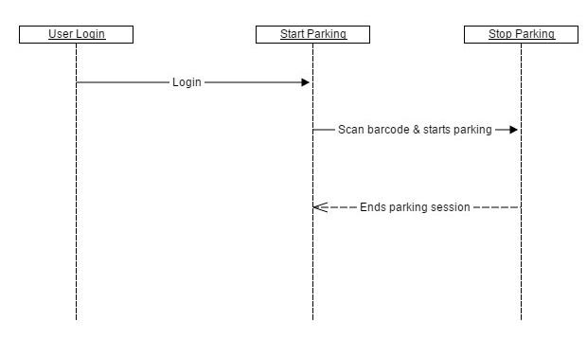

Figure : Sequence diagram for user

The login screen is the primary activity screen of the application. It allows the user to input login details, if the user is existing otherwise it also has button for the new user registration. The activity takes the credentials and authenticates the user. If the user is valid then it navigates to the parking activity screen.

The activity screen has text fields of parking lot and buttons to scan QR code and start session, before parking user can find the available parking lots by selecting slots availability in hidden menu. In this activity screen to avoid user input mistakes and provide efficient way to get parking spot details, QR code reader is used to read the code at the parking meter. The QR reader scans the code by using the camera of the smart phone and updates the fields of location, lot no, meter no and also updates the status of lot in the database. whenever the user starts the parking session by selecting start button then the application gets the GPS location of the spot and stores it in the local database, then it starts the timer of the parking session and estimated cost of the parking is displayed.

Here, the session activity screen provides Show location button to track the parked car in the parking session. So, the people can easily reach to the vehicle after completing their work. When the user selects the stop button to end the parking session, it displays the confirmation dialog box to end session also with total amount. Therefore parking session only ends if the user agrees to end. After the session ended the record in the database is updated with session end time, total amount and status to 1.

**User Menu:**

**Slot Availability:**

This provides layout of available parking lots, so the user can decide where to park the vehicle.

**Price Calculator:**

This application also allows the user to get estimated rates of particular parking areas. So, the user can calculate the price for the parking before starting the session.

**Reports:**

The parking sessions in daily figures, weekly, monthly and between From date and To date period of the user can be tracked in anytime by selecting reports from the menu.

**Admin:**

Admin can only login by selecting admin login in hidden menu of login screen. Admin is the authorized personal of the application, the login details are the default details created by the application developer. The admin has the access to add location, block user, unblock user and to check reports.

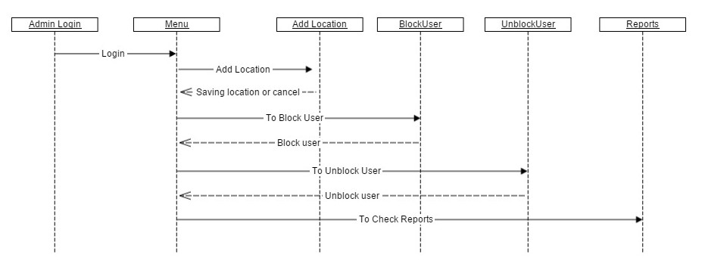

Figure : Sequence diagram for admin

**Add Location:**

The administrator can add new parking location by specifying price per hour.

**Block User:**

The users can be restricted to access the application, if he/she violates the terms and conditions like payment failures etc.

**Un-Block User:**

This is to unblock the blocked users to allow access to the application.

**Reports:**

The transactions of all the users can be generated by daily figures, weekly, monthly and between from date and to date period.

**Software Requirements for Development:-**

Operating System : Windows/linux

Technology : Android

IDE : Eclipse ADT /Android studio

Database : Sqlite 3.0 or above

**Hardware Requirements:-**

Processor : i3 and above

RAM : 4GB and above

Hard Disk : 20 GB

Phone/tab : Android based Phone / Tab(version2.3 or above)

**User Interface/ Module features Diagrams:**

**Authentication Module:**

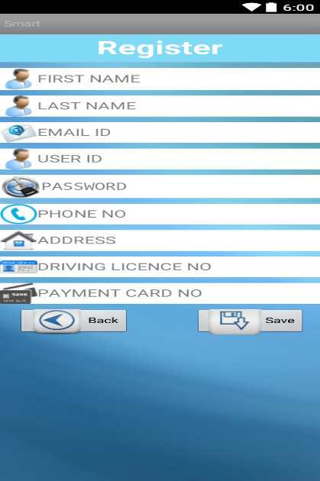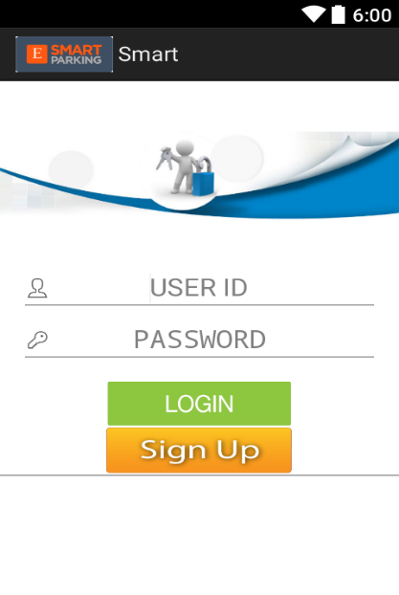

Figure 3: New Registration

Figure 4: Login Screen

**Parking Module:**

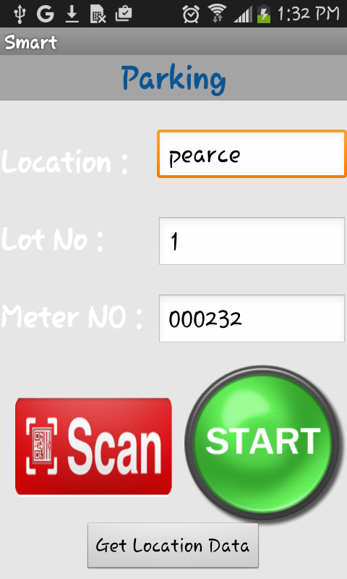 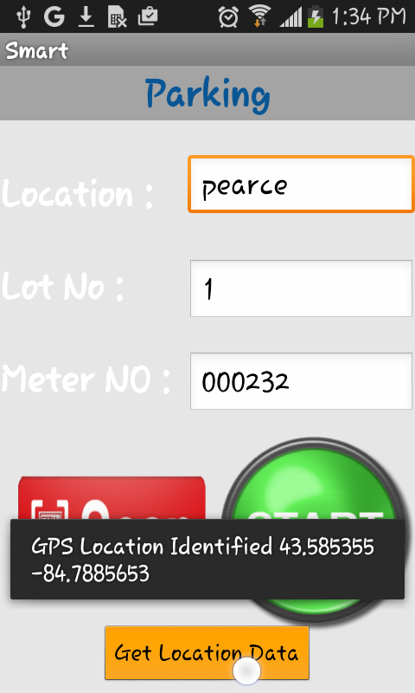

*Figure 4: GPS location of parking*

*Figure 3: Parking lot selection*

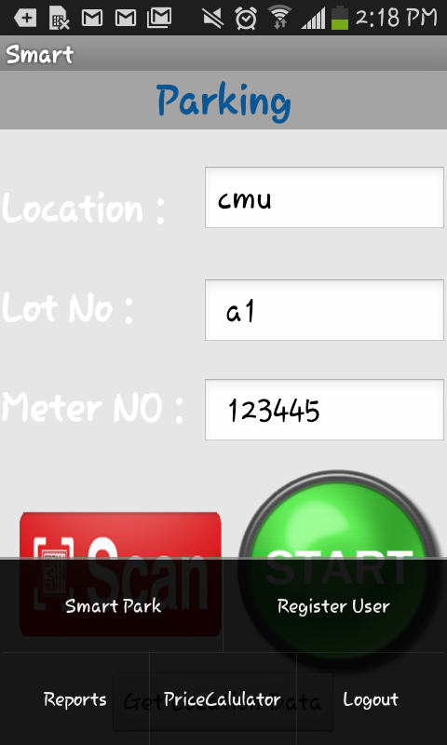 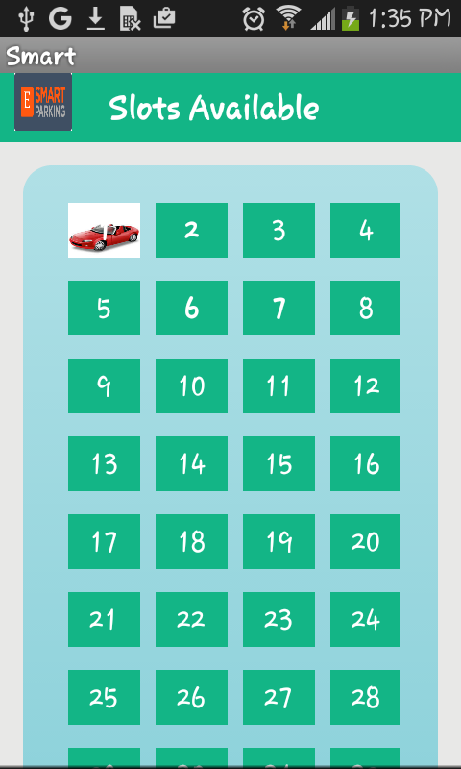

*Figure 6: Availability of parking slots*

*Figure 5: Menu for selecting other features*

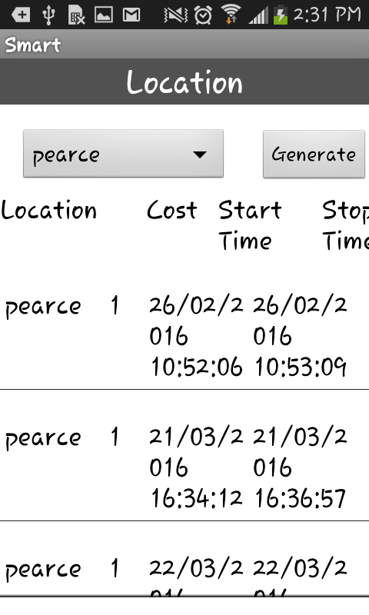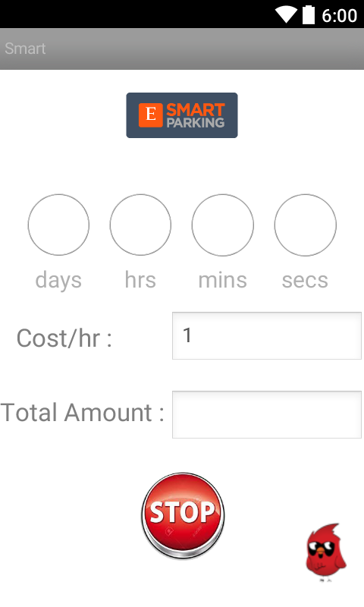 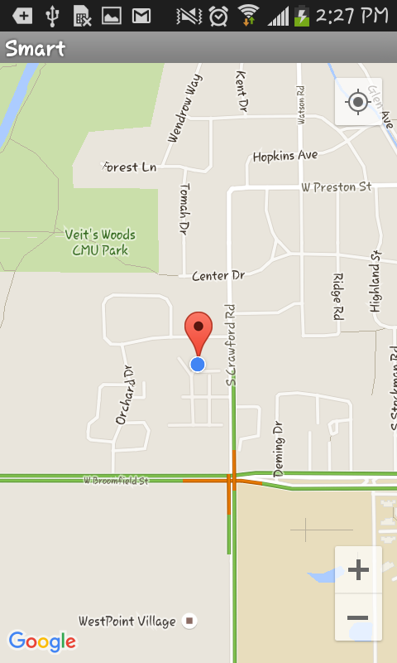

Figure 7: Parking session timer

Figure 8: Tracking parking spot

Figure 7: User reports by Location

Figure 9: Tracking parking spot

1. **FUTURE WORK**

This application has a scope of following additional features to provide more efficient and easy parking:

* For the accurate availability information of parking lots, sensors need to be placed at the parking meters to recognize manual parkers and application need to be integrated with system.
* Admin can update the availability layouts for all locations.
* Providing security feature by validating user with the verification code sent to user Mobile or Email at the registration process.
* Suggesting nearest and cheaper parking lots for the user.
* A feature for reserving parking lot. It is very useful for physically disabled persons.